HR APPLICANT PROCESSING SYSTEM
USER MANUAL
Comprehensive guide for Applicants, HR Staff, HR Manager, and Administrators
Applicant  Register, apply, upload docs, track status | HR Staff  Review, screen, schedule, evaluate | HR Manager  All HR Staff actions + final decisions | Admin  All access + users, maintenance, audit

Version 1.0 | HR Department

Table of Contents
1. System Overview 3
1.1 Purpose 3
1.2 System Users 3
1.3 Login Entry Points 3
2. Application Status Flow 4
3. Applicant Portal 5
3.1 Registration 5
3.2 Dashboard 5
3.3 Job Vacancies 5
3.4 My Application 6
3.5 My Documents 6
3.6 Status Tracking 6
4. HR Staff Module 7
4.1 Login 7
4.2 Dashboard 7
4.3 Applicant List 7
4.4 Applicant Review 7
4.5 Screening Page 8
4.6 Interview Schedule 8
4.7 Evaluation Page 9
4.8 Limitation: No Final Decisions 9
5. HR Manager Module 10
5.1 Login 10
5.2 Dashboard 10
5.3 All HR Staff Functions 10
5.4 Hiring Decision — Final Decision 10
5.5 Job Vacancy Management 11
5.6 Reports 11
6. Admin Module 12
6.1 Login 12
6.2 Manage Users 12
6.3 Maintenance 12
6.4 Audit Trail 12
7. Troubleshooting & Common Questions 13
8. Quick Reference — Who Can Do What 14

1. System Overview

1.1 Purpose
The HR Applicant Processing System is a Windows-based application that manages the complete hiring lifecycle — from job posting and applicant registration all the way through document verification, interview scheduling, evaluation, and final hiring decisions. It is designed for use by four types of users: Applicants, HR Staff, HR Managers, and System Administrators.

1.2 System Users
Applicant | Browses job vacancies, submits applications, uploads supporting documents, and tracks their application status.
HR Staff | Reviews submitted applications, screens qualifications, schedules interviews, and evaluates candidates. Cannot make final hiring decisions.
HR Manager | Performs all HR Staff functions, plus makes the final Accept / Reject / On Hold decision on candidates.
Admin | Has all HR Manager access plus can manage user accounts, configure system data (departments, job types), and view the full audit trail.

1.3 Login Entry Points
Two Separate Login Pages
Applicant Portal Login — for registered applicants only. Access via the main applicant portal.
Admin / HR Login — for HR Staff, HR Manager, and Admin roles. Separate URL/form from the applicant login.
Note: A new applicant must register first before they can log in. HR accounts are created by the Admin.

2. Application Status Flow
Every application moves through a defined series of statuses. Understanding this flow helps all users know where each applicant is in the hiring process.

Status | Set By | Meaning
Draft | Applicant | Application created but not yet submitted.
Submitted | Applicant | Applicant clicked Submit — HR can now see it.
Under Review | HR Staff / Manager | HR clicked Start Review on the application.
Shortlisted | HR Staff / Manager | Applicant passed screening — Qualified.
For Interview | HR Staff / Manager | Interview was scheduled for this applicant.
Assessment | HR Staff / Manager | Interview evaluation has been saved.
For Final Review | HRManager/ Admin | Schedule marked as Done — awaiting manager decision.
Accepted | HR Manager / Admin | Final decision: applicant is hired.
Rejected | HR Manager / Admin | Final decision: applicant is not hired.
On Hold | HR Manager / Admin | Decision deferred — applicant placed on hold.

Important Notes on Status Changes
All status changes are logged automatically with the timestamp and the name of the user who made the change.
Applicants can see their full status history on the Status Tracking page.
A rejected applicant (document rejection) can re-upload the document — it will return to Submitted status.
Once Accepted, the applicant cannot re-apply for the same job vacancy.
When an applicant is Accepted, the job vacancy slot count decreases by 1. If slots reach 0, the vacancy is automatically closed.

3. Applicant Portal
This section covers all features available to applicants after registering and logging in.

3.1 Registration
New applicants must register before they can log in and apply for jobs.

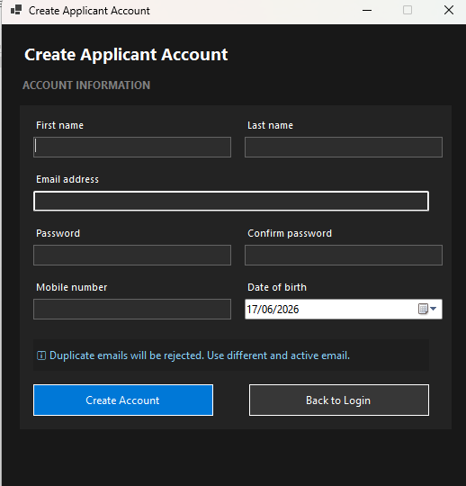

- Open the Applicant Portal login page.
- Click the Register / Sign Up link.
- Fill in: First Name, Last Name, Email address, and Password.
- Click Register. You will be redirected to the login page.
- Log in using your email and password.

3.2 Dashboard

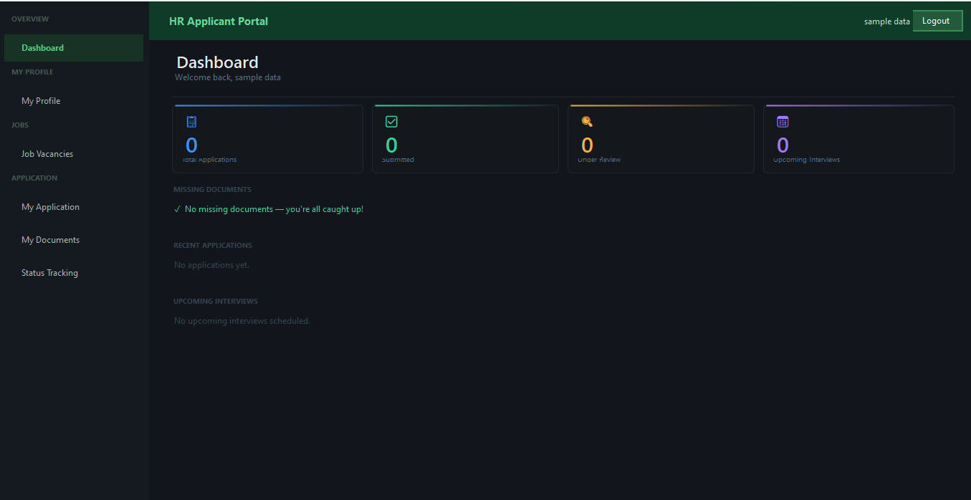

The dashboard gives a quick overview of your active applications and recent status changes. It contains quick links to all major sections.

3.3 Job Vacancies
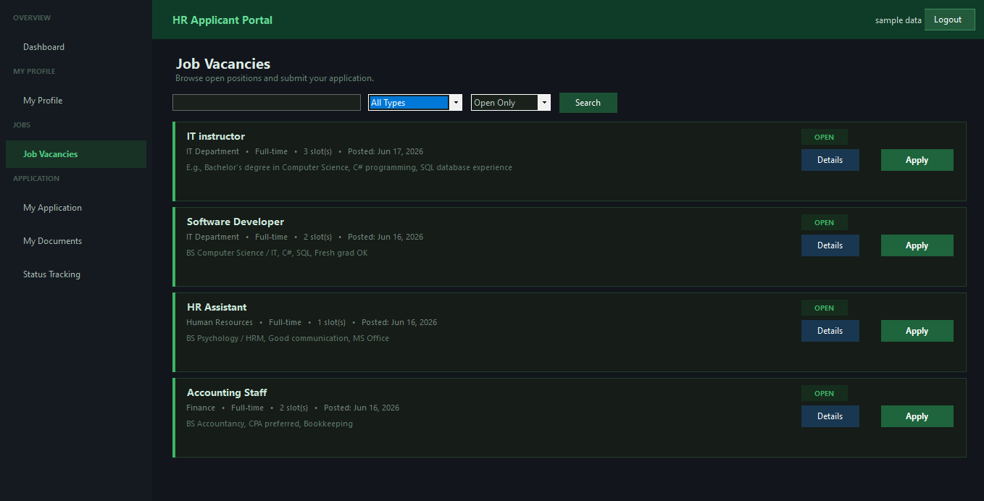
Browse all available positions posted by HR
- Use the search bar to filter by job title or department.
- Use the Employment Type dropdown to filter by Full-time, Part-time, Contractual, etc.
- Set the Status filter to Open Only to see only positions you can apply for.
- Each job card shows: title, department, employment type, slots remaining, posted date.

When Can You Apply?
The job must have status: Open.
The job must have at least 1 slot remaining.
You must not have an existing application for the same job.
You must not already be Accepted for the same job vacancy.

- Click Apply on a job card you want to apply for.
- Confirm the prompt. A Draft application is created automatically.
- Your document slots for that job are also created (all start as Missing).

3.4 My Application
Fill in the details of your application before submitting.

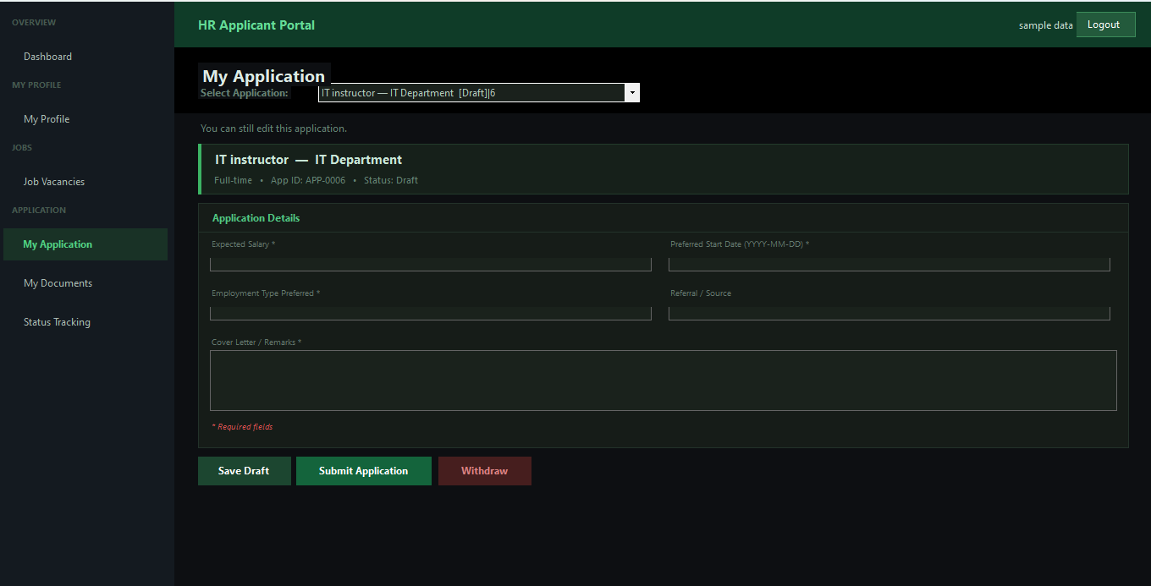

- Select the application from the dropdown if you have applied for multiple jobs.
- Fill in: Cover Letter, Expected Salary, Preferred Start Date, Employment Type Preference, Referral Source.
- Review your personal information and make sure your profile is complete.
- When ready, click Submit Application. Status changes from Draft to Submitted.

3.5 My Documents
Upload the required supporting documents for your application.

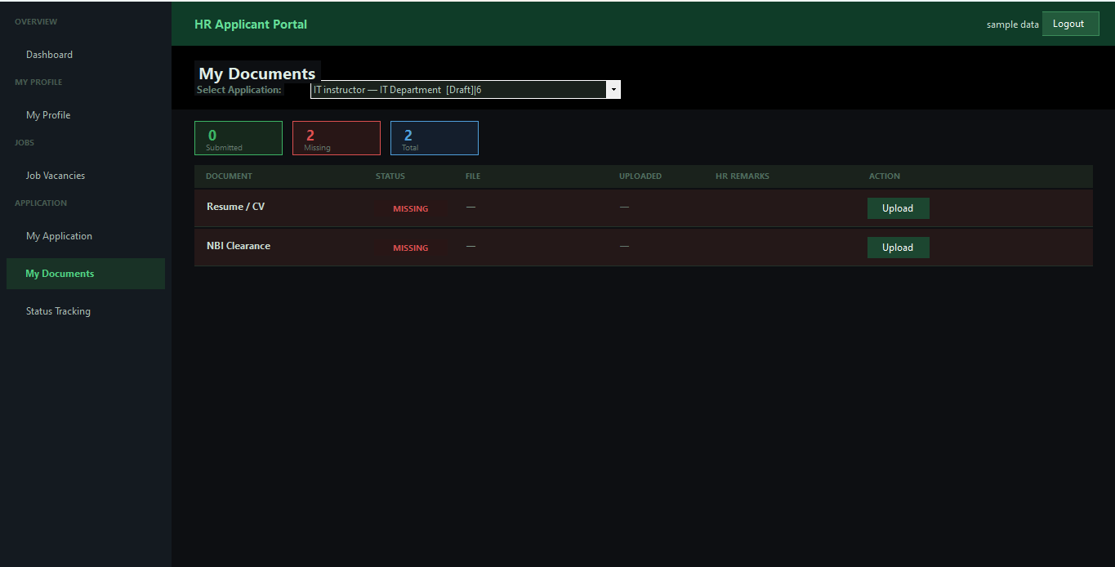

- Each required document has a slot showing its current status.
- Click Upload on a slot to select your file (PDF, DOCX, JPG, PNG accepted).
- Once uploaded, the slot status changes to Submitted.
- HR Staff or HR Manager will review your documents and either Accept or Reject them.

Document Statuses Explained
Missing — The document has not been uploaded yet.
Submitted — You have uploaded a file, waiting for HR review.
Accepted — HR has approved this document. No further action needed.
Rejected — HR rejected the document and left a reason. You can see the reason in the Remarks column and re-upload a corrected file.

Upload Lock
Documents can only be uploaded when your application status is Draft or Submitted.
Once HR starts reviewing (Under Review or later), uploads are locked.
Exception: If a document is Rejected, you can re-upload that specific document even in a locked state.

3.6 Status Tracking
View the complete history of your application status changes.
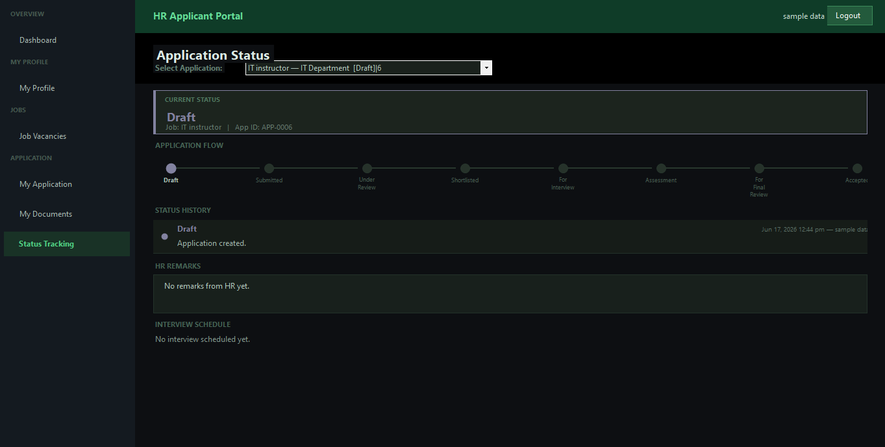

- Select the application from the dropdown.
- Each entry shows: Status name, Remarks/reason, Who changed it, and Date/time.
- This lets you track exactly where you are in the hiring process at any time.

4. HR Staff Module
HR Staff users handle the initial review, screening, interview scheduling, and evaluation of applicants. They cannot make final hiring decisions.

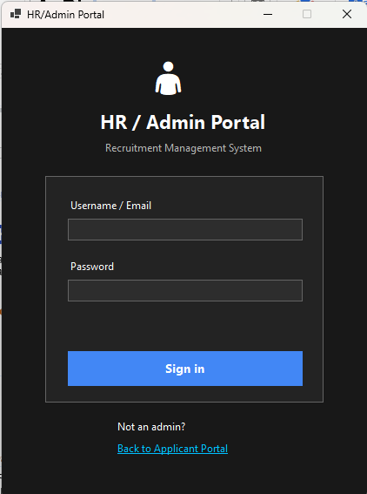
4.1 Login

- Open the Admin / HR Login page (separate from the applicant portal).
- Enter your Username and Password.
- The system will detect your role and load the HR Staff interface.

4.2 Dashboard

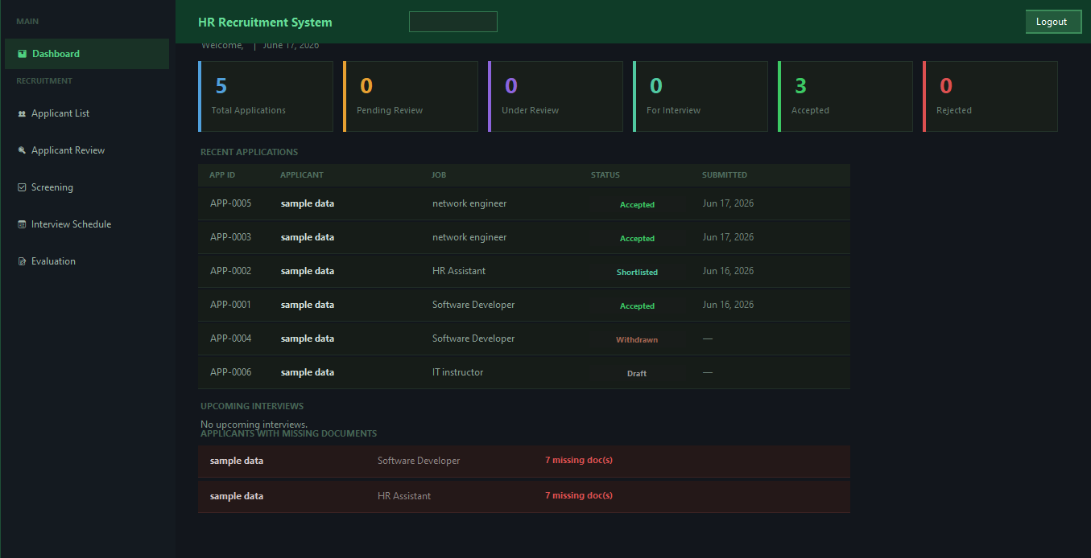
The HR Staff dashboard shows: number of pending reviews, number of scheduled interviews for today, recent applicant activity, and quick navigation links.

4.3 Applicant List
View all submitted applications.

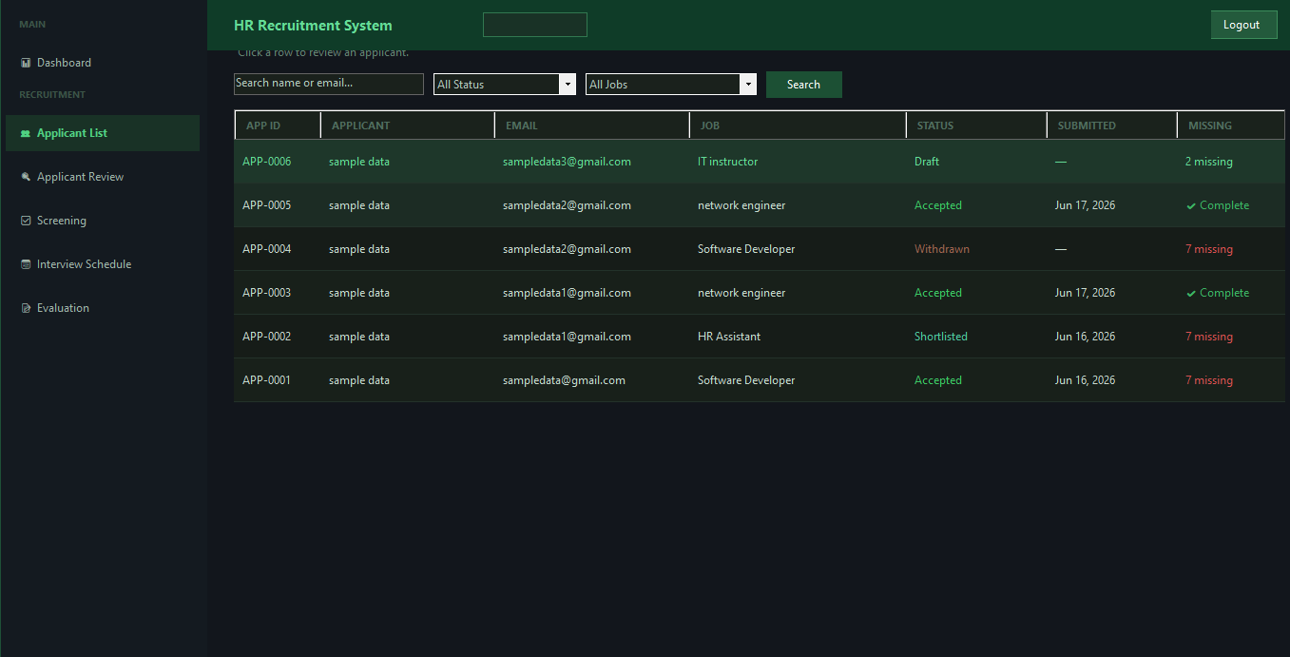

- Filter applicants by status, department, date range, or search by name.
- Click any row to open that applicant's full review page.

4.4 Applicant Review
The review page shows the applicant's full profile and all submitted documents.

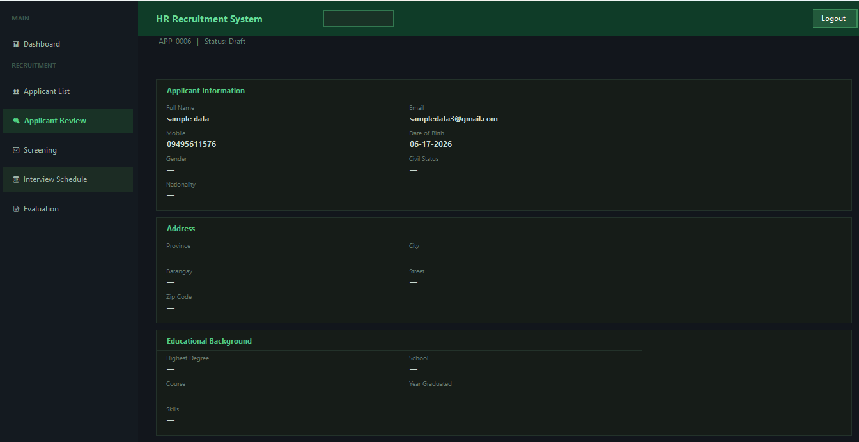

Reviewing Documents
- Each submitted document shows: name, status, uploaded file name, and current HR remarks.
- Click View File to open the uploaded document.
- Type a remark in the Remarks field if needed.
- Click Accept to approve the document. Status changes to Accepted.
- Click Reject to open a rejection dialog. Enter a reason and click Reject. Status changes to Rejected and the applicant will see your reason.

Starting the Review
- When the application status is Submitted, a Start Review button is shown.
- Click Start Review. Status changes to Under Review.
- A guidance banner appears directing you to the Screening page next.

4.5 Screening Page
Determine whether an applicant meets the qualifications for the position.

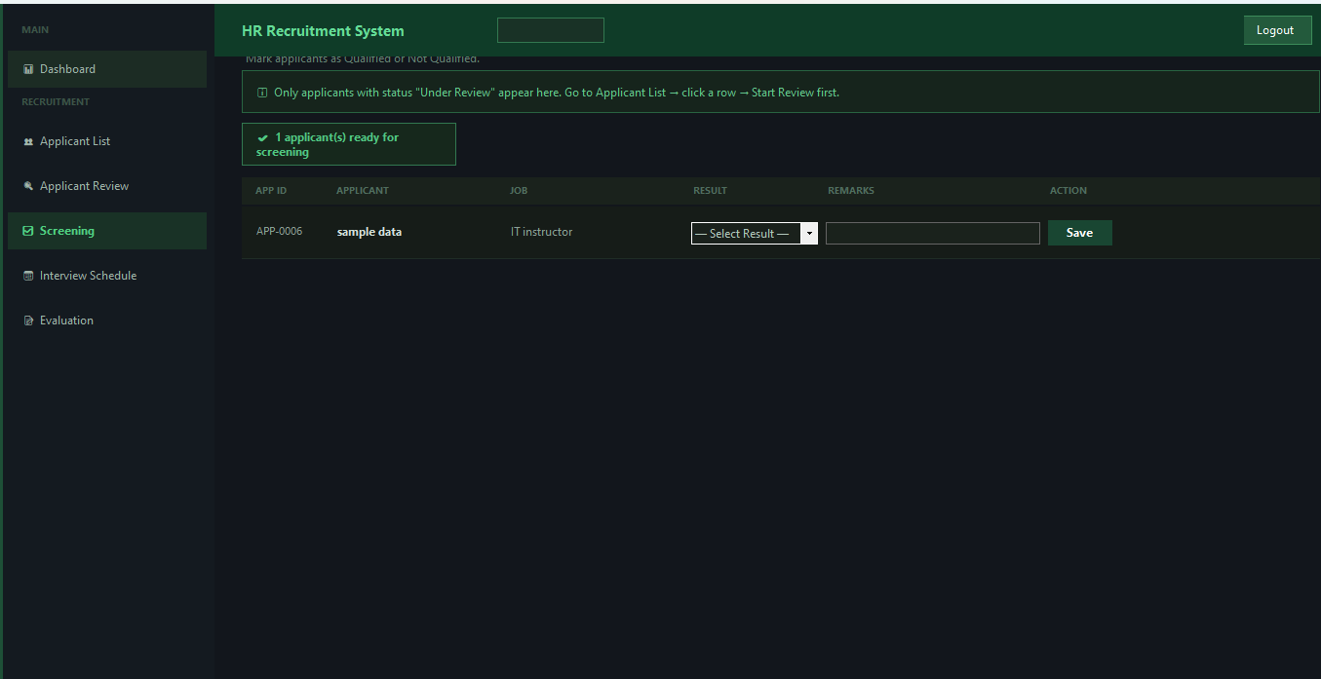

- Only applicants with status Under Review appear here.
- Review qualifications and documents, then select Qualified or Not Qualified.
- If Qualified: Status changes to Shortlisted.
- If Not Qualified: Status changes to Rejected with your remarks as the reason.

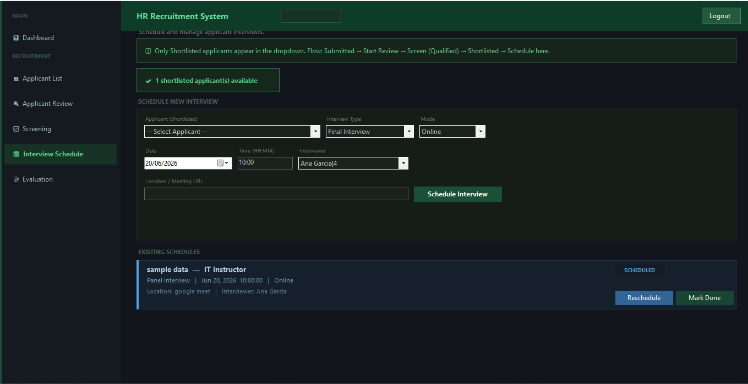
4.6 Interview Schedule
Schedule interviews for shortlisted applicants.

Who Appears in the Dropdown?
Only applicants with status Shortlisted appear in the Schedule New Interview dropdown.
If no one is listed, check the Screening page and mark qualified applicants first.

Scheduling a New Interview
- Select the applicant from the dropdown (Shortlisted only).
- Choose the Interview Type (loaded from database).
- Select Mode: Online, On-site, or Phone.
- Set the Date (must be at least tomorrow).
- Enter the Time in HH:MM format (e.g., 10:00 or 14:30).
- Select the Interviewer from the HR users list.
- Enter the Location or Meeting URL.
- Click Schedule Interview. Status changes to For Interview.

Rescheduling
- On any Scheduled interview card, click Reschedule.
- Change the date, time, or location and click Save Changes.

Marking as Done
Important: Evaluation Must Come First
You cannot mark an interview as Done unless an evaluation has been saved for it.
If no evaluation exists, a warning will appear: Please go to the Evaluation section first.
Complete the evaluation, then come back to Mark as Done.

- Click Mark Done on a Scheduled interview card.
- System checks for an evaluation first. If found, it marks the schedule as Completed.
- Application status changes to For Final Review.
- Status history is updated with remarks.

4.7 Evaluation Page
Record scores and outcomes for completed interviews.

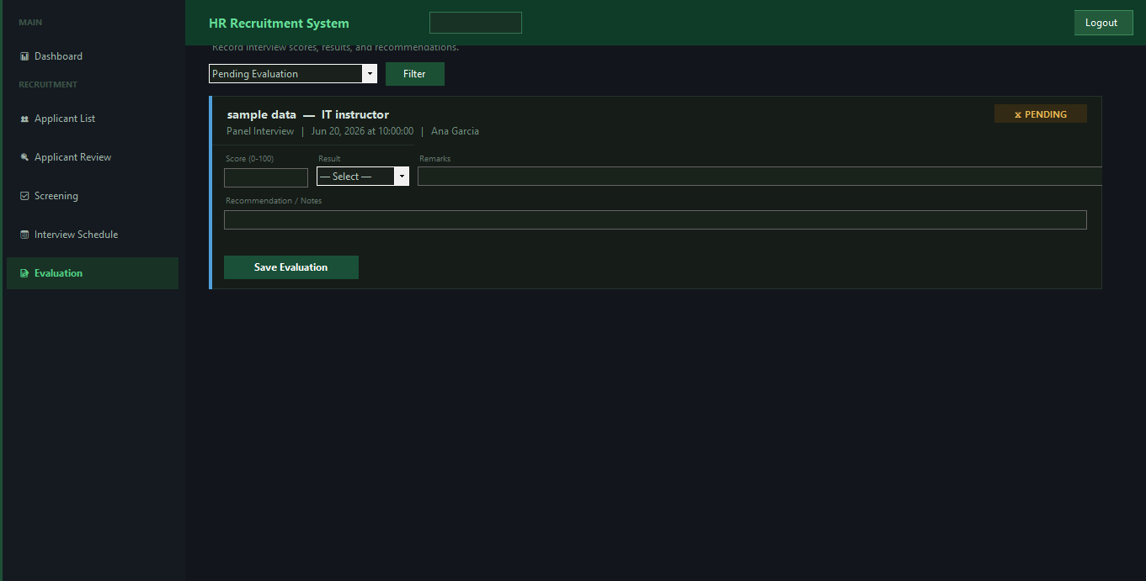

- Only Scheduled interviews (status = Scheduled) appear on this page.
- Click Add Evaluation (or Edit Evaluation if one already exists).
- Fill in: Score (0–100), Result (Pass / Fail), Remarks, Recommendation.
- Click Save Evaluation.
- Application status changes to Assessment. This is logged in status history.

After Evaluation Flow
Save Evaluation → Status: Assessment
Go back to Schedule page → Mark as Done → Status: For Final Review
For Final Review applications become available to HR Manager for the hiring decision.

4.8 Limitation: No Final Decisions
HR Staff Cannot Accept or Reject Applicants
HR Staff can only make recommendations through evaluations.
The final Accept, Reject, or On Hold decision requires HR Manager or Admin role.
After evaluation and marking as Done, hand the application off by notifying the HR Manager.

5. HR Manager Module
HR Managers have all the capabilities of HR Staff, plus the exclusive ability to make final hiring decisions. They also manage job vacancies and access reports.

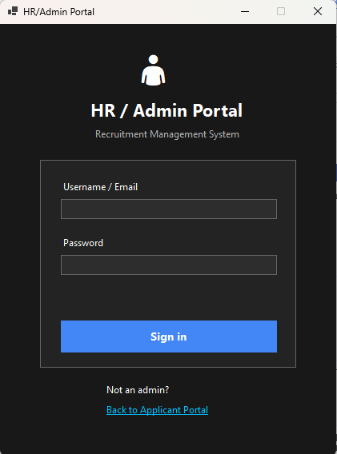
5.1 Login

- Open the Admin / HR Login page.
- Enter your Username and Password (role: HR Manager).
- The HR Manager interface loads with 9 sidebar items.

5.2 Dashboard

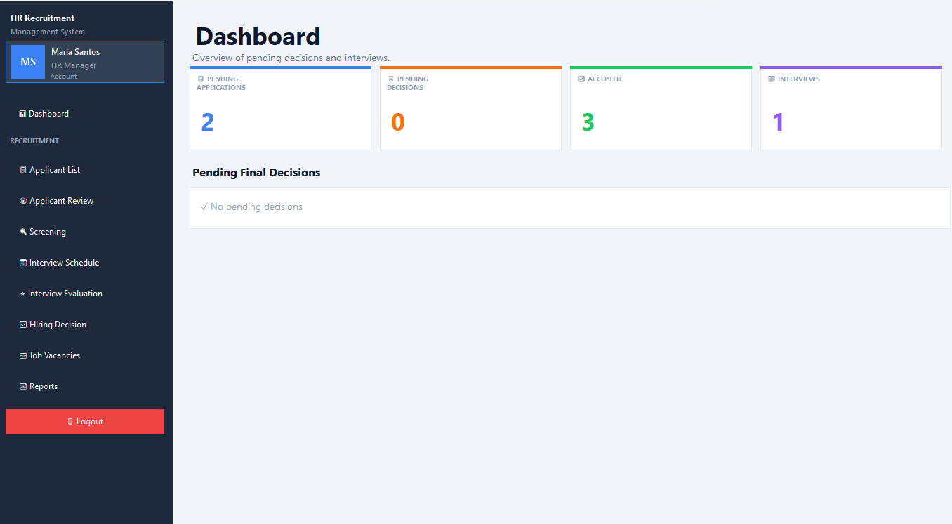

The manager dashboard shows the complete hiring pipeline: total applicants by status, recent hires, department breakdown, and vacancy status.

5.3 All HR Staff Functions
HR Managers can perform every action available to HR Staff including: Applicant List, Applicant Review, Document Accept/Reject, Screening, Interview Scheduling, Evaluation, and Marking as Done. Refer to Section 4 for detailed instructions on those steps.

5.4 Hiring Decision — Final Decision
This is the exclusive HR Manager function. Only applications with status For Final Review appear here.

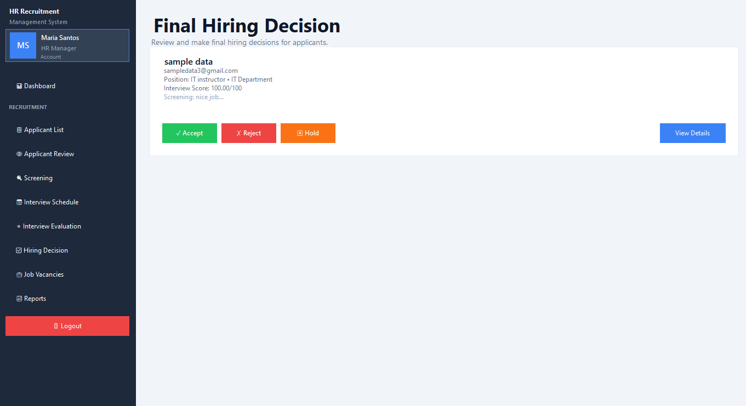

Who Can See This Page?
HR Manager and Admin only.
Only applications with status: For Final Review are listed.
Applications reach this status after: Evaluation saved (Assessment) + Schedule marked Done.

Making the Decision
- Open the Hiring Decision page or find the applicant on the Applicant Review page.
- Three buttons appear: Accept, Reject, On Hold.
- Click the appropriate button.
- A dialog appears asking for Remarks. Enter your reason or notes.
- Click Confirm. The decision is saved and the status is updated.

What Happens on Accept?
Application status changes to Accepted.
The job vacancy's available slot count decreases by 1.
If slots reach 0, the job vacancy is automatically closed (status: Closed).
The accepted applicant's Apply button is locked for that job — they cannot re-apply.
A hiring decision record is saved with the decision, remarks, and decided-by name.

5.5 Job Vacancy Management

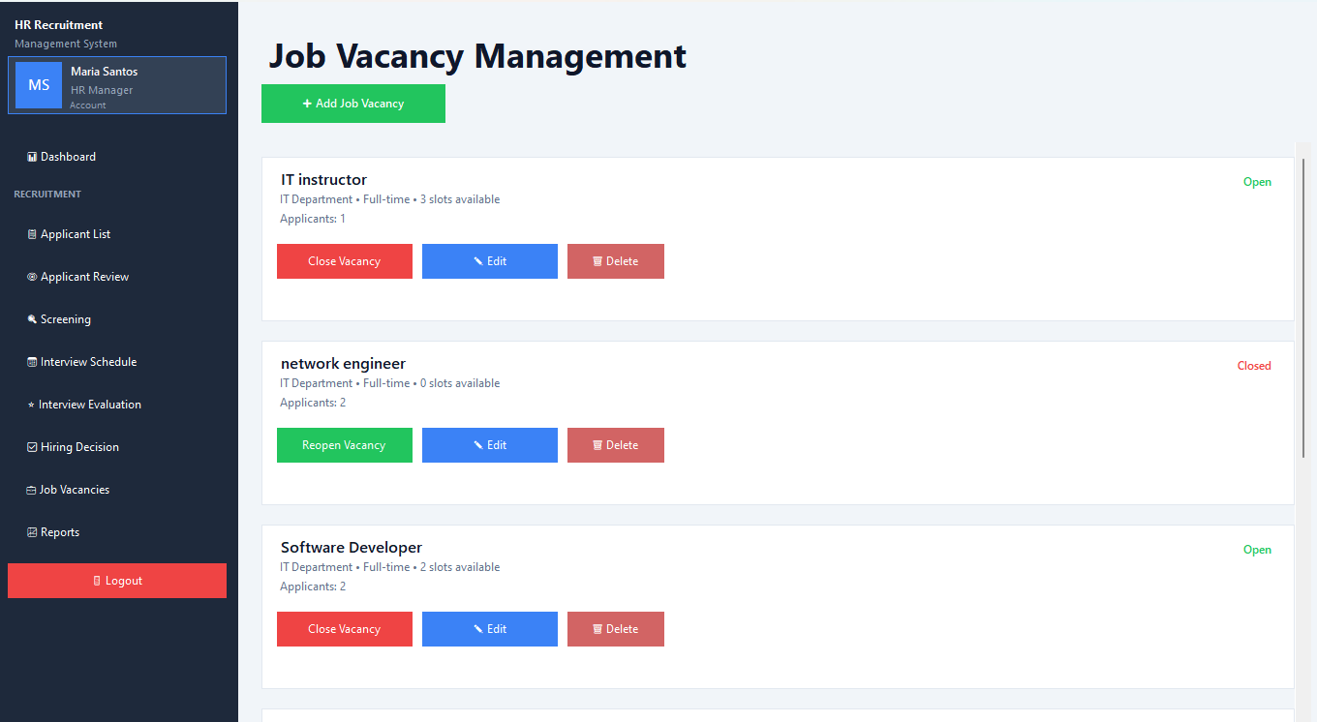
HR Managers create and manage job postings.

Adding a New Vacancy
- Click Add Job Vacancy.
- Enter the Job Title.
- Select the Department.
- Select Employment Type (Full-time, Part-time, Contractual, Project-based, Internship).
- Set the number of Slots (minimum 1).
- Click Add Vacancy. The job is published with status Open.

Editing a Vacancy
- Find the vacancy in the list and click Edit.
- Adjust the number of available slots.
- Click Save Changes.

Opening and Closing a Vacancy
- Click the Close / Open toggle button on a vacancy card.
- A vacancy can only be re-opened if it has at least 1 slot available.
Slot Rules
Cannot open a vacancy with 0 slots — edit the vacancy and add slots first.
When an applicant is accepted, 1 slot is automatically deducted.
When slots reach 0 the vacancy auto-closes — no further applicants can apply.
HR Manager can manually add slots at any time via the Edit button to reopen a closed vacancy.

5.6 Reports
Access hiring reports including applicant pipeline summaries and interview statistics. Use filters to narrow by date range, department, or status.
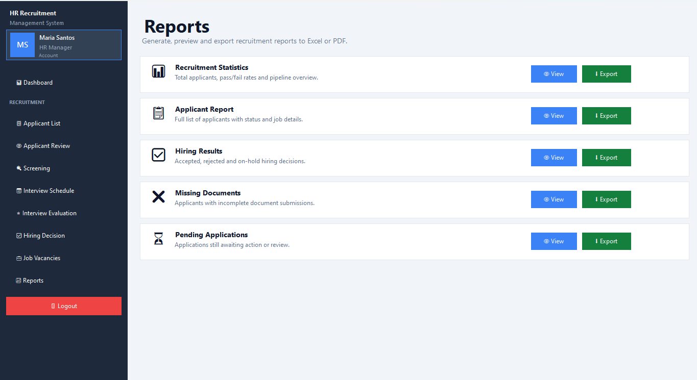

6. Admin Module
The Admin role has all HR Manager capabilities plus exclusive access to user management, system maintenance, and the audit trail. There are 12 sidebar items in total.


6.1 Login

- Open the Admin / HR Login page.
- Enter your Admin username and password.
- The full Admin interface loads with all 12 sidebar items.

6.2 Manage Users
Create and manage HR Staff, HR Manager, and Admin accounts.

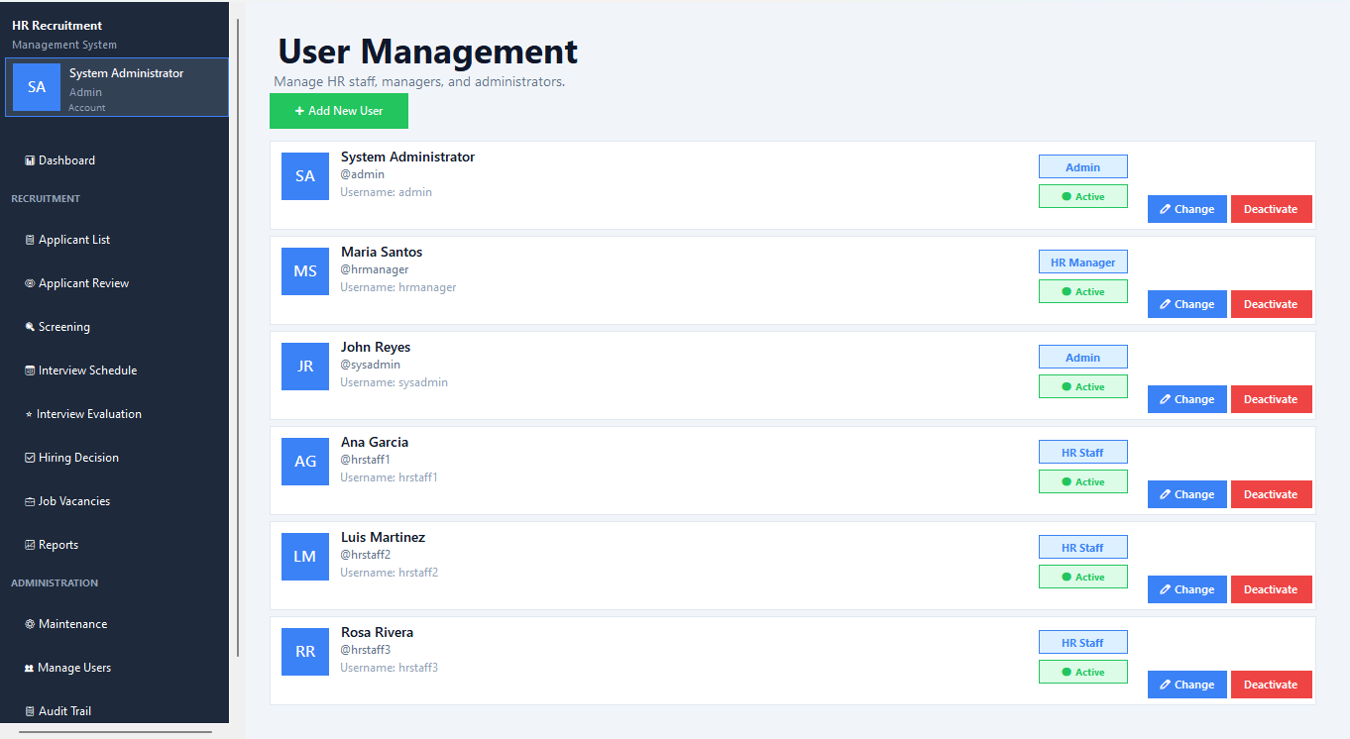

- Click Add User to create a new HR account.
- Fill in: Full Name, Username, Email, Password, and Role (HR Staff / HR Manager / Admin).
- Toggle a user as Active or Inactive. Inactive users cannot log in.
- Edit existing user details as needed.

6.3 Maintenance
Configure system reference data used across all modules.

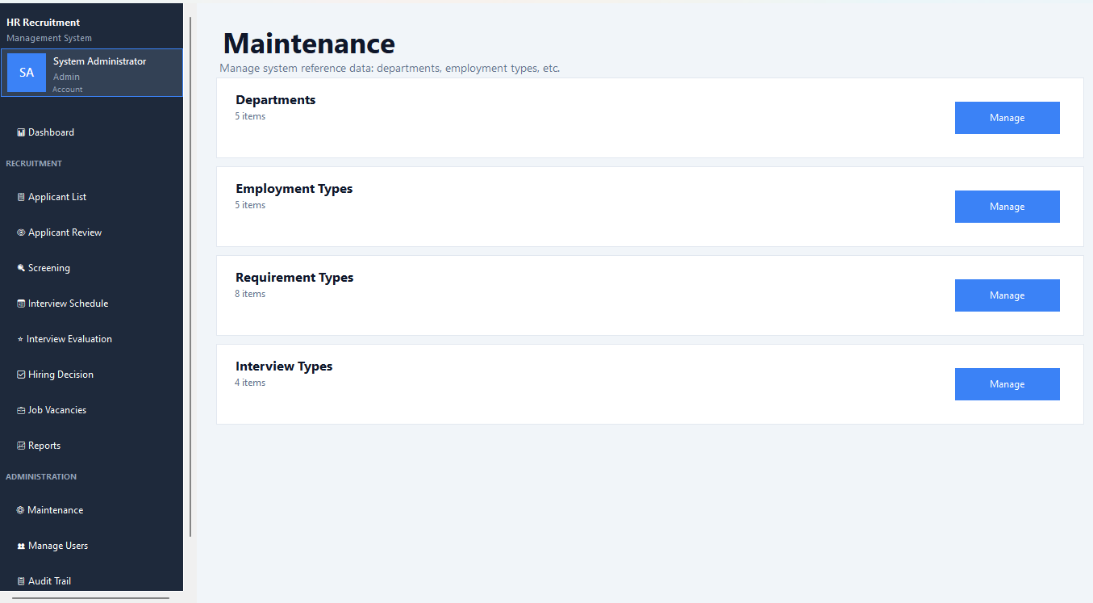

Departments | Add, edit, or deactivate departments. Departments appear in job vacancy and applicant data.
Interview Types | Define types of interviews (e.g., Technical, HR, Final). Active types appear in the interview scheduling dropdown.
Requirement Types | Define document requirements (e.g., Resume, NBI Clearance, TOR). Active types auto-populate applicant document slots on application.

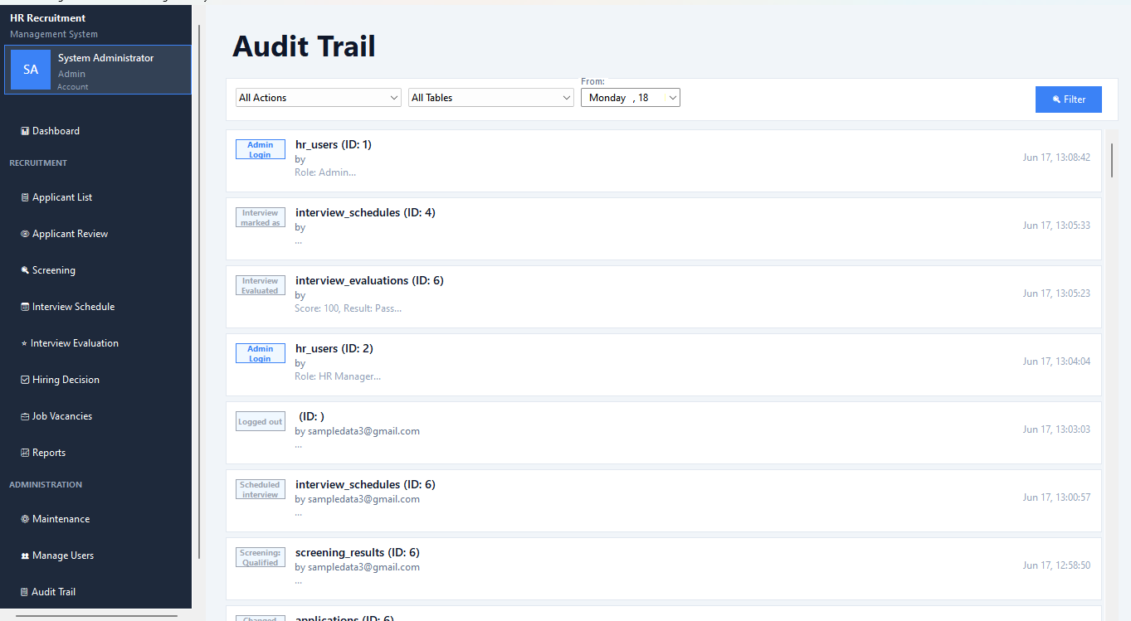
6.4 Audit Trail
Every significant action in the system is logged and viewable in the Audit Trail.

- Actions logged include: logins, application status changes, document uploads, interview scheduling, evaluations, hiring decisions, user management, and more.
- Each log entry shows: Action taken, Table affected, Record ID, Details, User who did it, and Timestamp.
- Filter logs by date range or user to investigate specific events.

7. Troubleshooting & Common Questions

Q | Applicant cannot apply for a job  Check: Is the vacancy Open? Does it have slots > 0? Has the applicant already applied or been Accepted for it?

Q | Mark as Done button shows a warning  The interview must have an evaluation saved first. Go to the Evaluation page, add the score and result, then return to the Schedule page.

Q | Cannot re-open a Closed vacancy  The vacancy has 0 slots. Click Edit on the vacancy and increase the slot count. Then the Open button will work.

Q | Document still shows Rejected after re-upload  When an applicant re-uploads a rejected document, it returns to Submitted status. HR staff or manager must Accept it to change it to Accepted.

Q | HR Staff cannot see the Accept/Reject buttons for hiring  Final hiring decisions (Accept/Reject/On Hold on the application level) are restricted to HR Manager and Admin roles only.

Q | Applicant status jumped to Accepted but documents aren't validated  Document acceptance/rejection is separate from the application Accept decision. Review documents independently using the Accept/Reject buttons on each document row.

Q | Applicant does not appear in interview scheduling dropdown  The applicant must have status Shortlisted. Go to the Screening page and mark them as Qualified first.

8. Quick Reference — Who Can Do What

Action | Applicant | HR Staff | Manager | Admin
Register & login as applicant | ✓ | ✗ | ✗ | ✗
Browse job vacancies | ✓ | ✗ | ✗ | ✗
Apply for a job | ✓ | ✗ | ✗ | ✗
Upload / replace documents | ✓ | ✗ | ✗ | ✗
Track application status | ✓ | ✗ | ✗ | ✗
View applicant list | ✗ | ✓ | ✓ | ✓
Start Review (Submitted → Under Review) | ✗ | ✓ | ✓ | ✓
Accept / Reject documents | ✗ | ✓ | ✓ | ✓
Screening (Shortlist / Reject) | ✗ | ✓ | ✓ | ✓
Schedule interview | ✗ | ✓ | ✓ | ✓
Reschedule interview | ✗ | ✓ | ✓ | ✓
Save interview evaluation | ✗ | ✓ | ✓ | ✓
Mark interview as Done | ✗ | ✓ | ✓ | ✓
Final Accept / Reject / On Hold | ✗ | ✗ | ✓ | ✓
Manage job vacancies | ✗ | ✗ | ✓ | ✓
View reports | ✗ | ✗ | ✓ | ✓
Manage HR user accounts | ✗ | ✗ | ✗ | ✓
System maintenance (dept, types) | ✗ | ✗ | ✗ | ✓
View audit trail | ✗ | ✗ | ✗ | ✓

